INTREBARI TESTE LABORATOR TS/ST 2025

Fiecare test are 3 intrebari (0.6 puncte), 1 din tema, iar 2 din curs.
Contents
TEST 1 1
TEST 2 5
TEST 3 12
TEST 4 13
TEST 5 14

TEST 1
Intrebarea din tema:
1. Calculati solutia ecuatiei: x^2+2=0 (sau orice ecuatie de gradul 2)
2. Se da numarul complex x=3+4j (oricare numar complex e bun). Calculati modulul, partea reala si partea imaginara.
3. Se da o ecuatie de gradul 2 cu radacini complexe... oricare dar usor de rezolvat. Reprezentati radacinile in plannul complex.
4. Sa se descompuna in suma de fractii simple expresia 1/((s+1)(s+2)).
5. Se da o ecuatie de gradul 2 (ex: x^2 + 4x +a). Determinati a astfel incat radacinile sa fie reale distincte/complexe sau reale si egale.
6. Calculați modulul și argumentul numărului complex: $z=\frac{1}{j+1}$
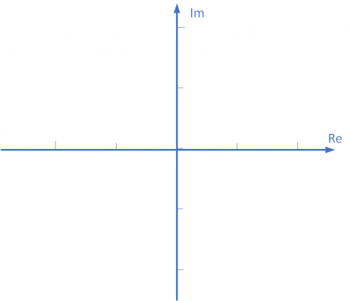
7. Place the numbers in the complex plane:
$z_{1}=-1-j$, $z_{2}=-1+j$, $z_{3}=1-j$, $z_{4}=1-j$

$z_{1}=1-2j$, $z_{2}=2j$, $z_{3}=j-1$, $z_{4}=j +1$

8. Find the solutions of the equation: $x^{3}+2x^{2}+x+2=0$

Intrebarile din curs (2 intrebari):
1. Desenam pe tabla un sistem cu functia de transfer H(s), intrarea U(s) si iesirea Y(s). Intrebare: daca H(s) si U(s) sunt date, cum se calculeaza y(t)?
2. Desenam pe tabla un sistem cu functia de transfer H(s), intrarea U(s) si iesirea Y(s). Daca U(s) si Y(s) sunt date cum se calculeaza functia de transfer?
3. Desenez un sistem cu intrarea u(t) si iesirea y(t). Cum se calculeaza functia de transfer?
4. Se da un sistem cu functia de transfer H(s) = (s+2)/s^2(s+3) sau orice alta functie de transfer pentru care polii si zerourile sunt vizibile sau se pot determina dintr-o ecuatie de gradul max 2. Care sunt polii si zerourile sistemului?
5. Se da un sistem cu functia de transfer: H(s) = (s+2)/(s^2+s+1). Care este ordinul sistemului?
6. Se da un sistem cu functia de transfer H(s) = (s+1)/(s^2+s+1). Care este ecuatia caracteristica?
7. Determinati polii si zerourile functiei de transfer: $H\left(s\right)=\frac{s^{2}}{s^{2}+3s+2}$
8. Determinati functia de transfer pentru un sistem descris de ecuatia diferentiala:
$$\frac{dy^{2}\left(t\right)}{dt^{2}}+2y\left(t\right)=3u\left(t\right)$$
(a) $G\left(s\right) =\frac{3}{s^{2}+2}$ (b) $G\left(s\right) =\frac{3}{s^{2}+2s}$ (c) $G\left(s\right) = \frac{s^{2}+2}{3}$
(d) $G\left(s\right)=\frac{y^{2}\left(t\right)+2}{3u\left(t\right)}$ (e) $G\left(s\right)=\frac{3u\left(t\right)}{y^{2}\left(t\right)+2y\left(t\right)}$
9. Determine the transfer function for a system having the input $u\left(t\right)$ and the output $y\left(t\right)$, described by the differential equation:
$$3\frac{d^{2}y\left(t\right)}{dt^{2}}+9\frac{dy\left(t\right)}{dt}=\frac{du\left(t\right)}{dt}+u\left(t\right)$$
(a) $G\left(s\right)=\frac{s+1}{3s^{2}+9s}$ (b) $G\left(s\right)=\frac{s+1}{3s^{2}+9}$ (c) $G\left(t\right)=\frac{u\left(t\right)+1}{3y^{2}\left(t\right)+9y\left(t\right)}$
(d) $G\left(s\right)=\frac{3s^{2}+9s}{s+1}$ (e) $G\left(t\right)=\frac{3y^{2}\left(t\right)+9y\left(t\right)}{u\left(t\right)+1}$
10. Pentru sistemul cu functia de transfer $H\left(s\right)=\frac{s+2}{s^{2}+2s+2}$, alegeti doar afirmatiile adevarate:
(a) sistemul este de ordinul 2
(b) sistemul este de ordinul 1
(c) sistemul are poli complex conjugați
(d) ecuatia caracteristica a sistemului este: s+2 = 0
(e) sistemul are zerouri complex conjugate
(f) toti polii si zerourile sistemului au valori reale

11. Daca pentru un sistem liniar si continuu sunt cunoscute: semnalul de intrare $r\left(t\right)$ si semnalul de iesire $y\left(t\right)$, cum ati calcula functia de transfer?

12. What is the characteristic equation of a system? (in your own words)
13. For the system described by the transfer function $G\left(s\right)=\frac{s+5}{s^{2}+s+2},$ determine the order of the system and the characteristic polynomial and explain how you determined them.

14. Determine the poles and the zeros of the transfer function:
$$G\left(s\right)=\frac{s^{2}-1}{s^{3}+4s}$$
$$G\left(s\right)=\frac{1}{s^{2}\left(s+1\right)\left(s-2\right)}$$
$$G\left(s\right)=\frac{s}{s^{2}+2s+2}$$
$$G\left(s\right)=\frac{s^{2}}{\left(s+3\right)\left(s^{2}+4s+4\right)}$$
$$G\left(s\right)=\frac{s}{\left(s+3\right)\left(s^{2}+3s+2\right)}$$
15. A system has the input signal $u\left(t\right)$ and the output signal $y\left(t\right)$. The transfer function for this system is:
(a) $G\left(s\right)=\frac{L\{y\left(t\right)\}}{L\{u\left(t\right)\}}$ (b) $G\left(s\right)=\frac{L\{u\left(t\right)\}}{L\{y\left(t\right)\}}$ (c) $G\left(t\right)=\frac{y\left(t\right)}{u\left(t\right)}$ (d) $G\left(s\right)=L \left\{\frac{y\left(t\right)}{u\left(t\right)}\right\}$
16. Desenati o schema bloc cu doua sisteme in conexiune paralela.
17.Draw a block diagram with two systems in a negative feedback conection.

TEST 2

Intrebarea din tema:
1. Se da ecuatia diferentiala $\frac{d^{2}y\left(t\right)}{dt^{2}}+2=\frac{du\left(t\right)}{dt}$. Calculati functia de transfer pentru conditii initiale nule.
2. Determine the transfer function of the following system (zero initial conditions): $\frac{d^{2}y\left(t\right)}{dt^{2}}+\frac{d y\left(t\right)}{dt}=u(t)$
3. Se da functia de transfer H(s)=1/(s+1). Calculati raspunsul la impuls, avand in vedere ca transformata Laplace a lui e^{-at} este 1/(s+a).
4. Determine the transfer function H(s)=y(s)/u(s) for the following block diagram:
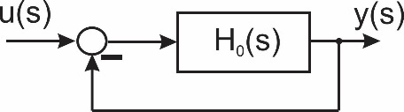
5. Determine the transfer function H(s)=y(s)/u(s) for the following block diagram:
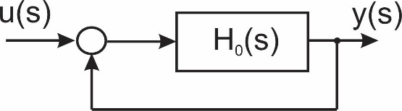
6. Find the transfer function for a system with the input u(t) and the output y(t), described by the differential equation:
$$4\frac{d^{3}y\left(t\right)}{dt^{3}}+\frac{d^{2}y\left(t\right)}{dt^{2}}-2\frac{dy\left(t\right)}{dt}=3u\left(t\right)$$
$$4\frac{d^{3}y\left(t\right)}{dt^{3}}+\frac{d^{2}y\left(t\right)}{dt^{2}}-2y\left(t\right)=3\frac{du\left(t\right)}{dt}$$
$$\frac{d^{2}y\left(t\right)}{dt^{2}}+\frac{dy\left(t\right)}{dt}+2y\left(t\right)=\frac{d^{2}u\left(t\right)}{dt^{2}}$$
$$5\frac{d^{2}y\left(t\right)}{dt^{2}}+2y\left(t\right)=u\left(t\right)$$
$$u\left(t\right)=5\frac{d^{2}y\left(t\right)}{dt^{2}}+2y\left(t\right)$$
$$3\frac{du\left(t\right)}{dt}=4\frac{d^{3}y\left(t\right)}{dt^{3}}+\frac{d^{2}y\left(t\right)}{dt^{2}}-2y\left(t\right)$$

7. Pentru schema bloc din figura determinati functia de transfer echivalenta (in functie de H1, H2, H3 si H4).
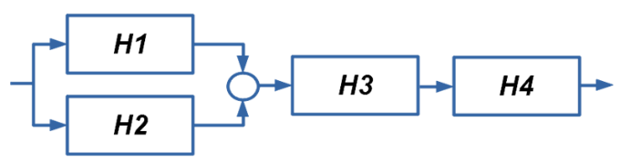

Intrebarile din curs (2 intrebari):
1. Se da un sistem cu functia de transfer H(s)=8/(s+4). Calculati constanta de proportionalitate K =? si constanta de timp T=?
2. What is the time consant for the transfer function H(s)=3/(2s+4)?
3. Desenati un raspuns la treapta periodic amortizat si evidentiati grafic suprareglajul.
4. Desenati cum arata un raspuns la treapta pentru un sistem de ordinul 2 subamortizat.
5. Draw the step response of a second order undamped system.
6. Se dau 4 functii de transfer:
$$G_{1}\left(s\right)=\frac{s-1}{s+4},G_{2}\left(s\right)=\frac{s+1}{s-4},G_{3}\left(s\right)=\frac{s-1}{s-4},G_{4}\left(s\right)=\frac{s+1}{s+4}.$$
Care dintre ele reprezinta sisteme stabile?
7. Sa calculeze factorul static de amplificare al sistemului H(s)=(s-2)/(s+4) (prin calculul limitei lim_{s->0} H(s)).
8. Determine the DC gain for the system H(s)=(s+2)/(s^2+3s+1) (by calculating the limit lim_{s->0} H(s)).
9. When is a system BIBO stable?
10. Draw the impulse response of a marginally stable system.
11. A linear system has the poles -3, 2, -1. Is the system stable, marginally stable, or unstable?
12. Determinati stabilitatea sistemului cu functia de transfer
$H\left(s\right)=\frac{s-1}{(s+4)(s-3)}.$ Argumentati raspunsul.

8. Alegeti functiile de transfer corespunzatoare unor sisteme stabile.
$$H_{1}\left(s\right)=\frac{s-1}{s^{2}+3s+2}$$
$$H_{2}\left(s\right)=\frac{s+1}{\left(s-1\right)\left(s+2\right)}$$
$$H_{3}\left(s\right)=\frac{s^{2}}{s^{3}+2s^{2}+1}$$
$$H_{4}\left(s\right)=\frac{1}{\left(s+3\right)\left(s+4\right)}$$
$$H_{5}\left(s\right)=\frac{1}{\left(s+3\right)\left(s+4\right)\left(s+5\right)\left(s-0.1\right)}$$
9. In figura de mai jos sunt reprezentate semnalele de intrare (u(t) - cu linie rosie) si de iesire (y(t) - cu linie albastra) pentru un sistem liniar si continuu. Scrieti numerele corespunzatoare pentru: suprareglaj si timp de răspuns.
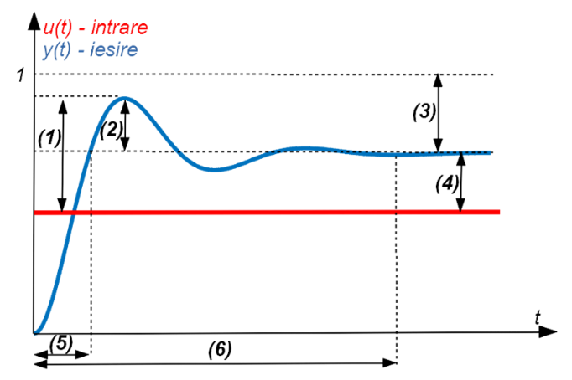

10. Alegeti functiile de transfer corespunzatoare sistemelor care NU sunt stabile.
$$H_{1}\left(s\right)=\frac{s-1}{s^{2}+3s+2}$$
$$H_{2}\left(s\right)=\frac{s+1}{\left(s-1\right)\left(s-2\right)}$$
$$H_{3}\left(s\right)=\frac{s^{2}}{s^{2}-2s+1}$$
$$H_{4}\left(s\right)=\frac{1}{s^{2}\left(s+3\right)\left(s+4\right)}$$
$$H_{5}\left(s\right)=\frac{1}{\left(s+3\right)\left(s+4\right)}$$
11. For a first-order system, in the figure below are presented: in red - the input step signal u(t), in blue: the system response y(t). Place the characteristics of the system response in the correct location in the figure:
- settling time
- time constant
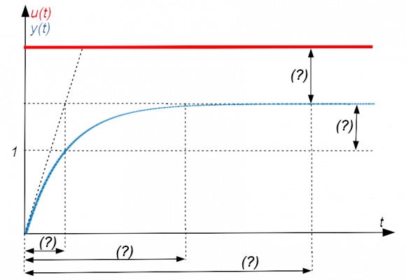

12. For a second-order system, in the figure below are presented: in red - the input step signal u(t), in blue - the system response y(t)
Place the characteristics of the system response in the correct location in the figure:
- settling time
- overshoot
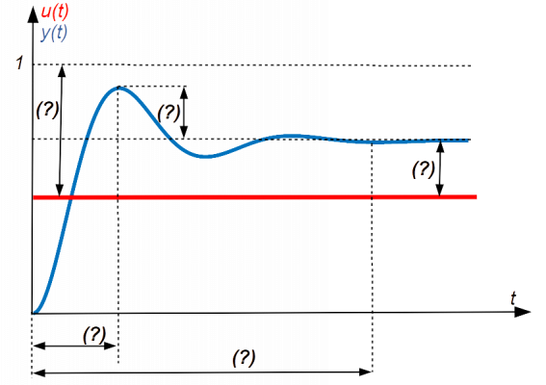
13. For a second-order system, in the figure below are presented: in red - the input step signal u(t), in blue - the system response y(t)
Place the characteristics of the system response in the correct location in the figure:
- settling time
- rise time
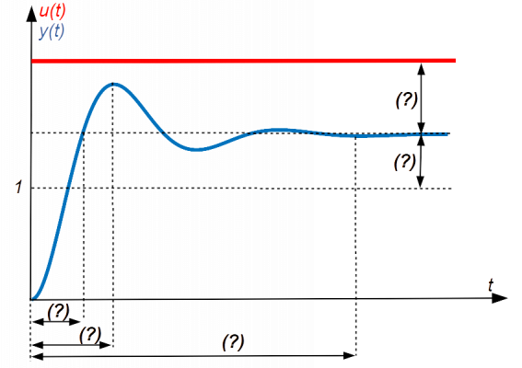
14.
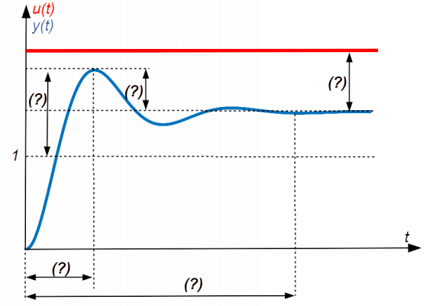
15.
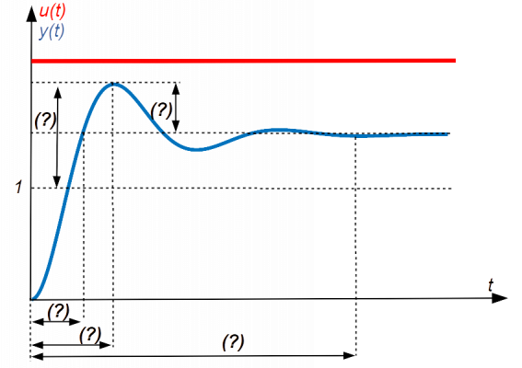
16.
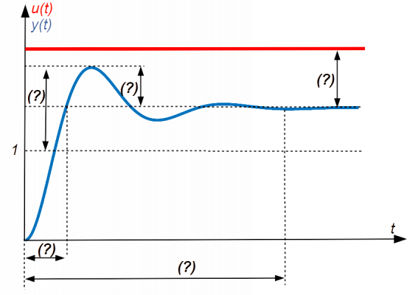
17. Find the gain constant K and the time constant T for the system:
$$G\left(s\right)=\frac{1}{17s+17}$$
$$G\left(s\right)=\frac{3}{5s+8}$$

Choose which of the following systems are stable, unstable, or marginally stable:
$$G\left(s\right)=\frac{s-1}{s+1}$$
$$G\left(s\right)=\frac{s+1}{s-1}$$
$$G\left(s\right)=\frac{1}{s^{2}\left(s+1\right)}$$
$$G\left(s\right)=\frac{1}{\left(s+1\right)\left(s-1\right)}$$
Choose which of the following systems are stable, unstable, or marginally stable:
$$G\left(s\right)=\frac{-5s+1}{s\left(10s+1\right)\left(2s+1\right)}$$
$$G\left(s\right)=\frac{2s+1}{s\left(10s+1\right)\left(-2s+1\right)}$$
$$G\left(s\right)=\frac{s+2}{\left(s^{2}+1\right)\left(s+1\right)\left(s+5\right)}$$
$$G\left(s\right)=\frac{-s+0.2}{\left(s^{2}+s+1\right)\left(s+1\right)}$$
Choose which of the following systems are stable, unstable, or marginally stable:
$$G\left(s\right)=\frac{s+2}{{\left(s^{2}+10\right)}^{2}{\left(2s+1\right)}^{2}}$$
$$G\left(s\right)=\frac{s+2}{s{\left(s+10\right)}^{2}{\left(2s+1\right)}^{2}}$$
$$G\left(s\right)=\frac{s\left(s+2\right)}{{\left(s+10\right)}^{2}{\left(2s+1\right)}^{2}}$$
$$G\left(s\right)=\frac{s+2}{\left(s^{2}+10\right){\left(2s+1\right)}^{2}}$$
Choose which of the following systems are stable, unstable, or marginally stable:
$$G\left(s\right)=\frac{s+2}{s\left(s-4\right)}$$
$$G\left(s\right)=\frac{s-2}{s\left(s+4\right)}$$
$$G\left(s\right)=\frac{s+2}{s\left(s+4\right)}$$
$$G\left(s\right)=\frac{s}{\left(s+2\right)\left(s+4\right)}$$

TEST 3

Intrebarea din tema:

Intrebarile din curs (2 intrebari):

TEST 4

Intrebarea din tema:

Intrebarile din curs (2 intrebari):

--------------------------------------------------------------------------------------------------------------

TEST 5

Intrebarea din tema:

Intrebarile din curs (2 intrebari):

